AI-Assisted Documentation & Docstring Assignment Report
Hall Ticket : 2303a51257
Name : SANGU UDAY
Task 1: Basic Docstring Generation

Prompt:
Write a Python function to return the sum of even and odd numbers in a list. Add manual Google-style docstring. Generate AI docstring. Compare both.

Implementation with Manual Google-Style Docstring:
def sum_even_odd(numbers):
"""Calculate sum of even and odd numbers in a list.
Args:
numbers (list[int]): List of integers.
Returns:
tuple: (sum_even, sum_odd)
Raises:
TypeError: If input is not a list.
"""
# Validate input type
if not isinstance(numbers, list):
raise TypeError("Input must be a list")
sum_even = 0 # Store even sum
sum_odd = 0 # Store odd sum
# Iterate through numbers
for num in numbers:
if num % 2 == 0:
sum_even += num
else:
sum_odd += num
return sum_even, sum_odd

AI-Generated Docstring (Simulated):
"""Return the sum of even and odd numbers from a list.
Parameters:
numbers: List of integers.
Returns:
Tuple containing even sum and odd sum.
"""

Code Explanation:
The function validates input type, iterates through list elements, classifies numbers as even or odd, and returns their respective sums.

Sample Output:
Input: [1,2,3,4,5]
Output: (6, 9)

Comparison:
Manual docstring includes structured sections (Args, Returns, Raises). AI version is concise but lacks error handling details and structured format.
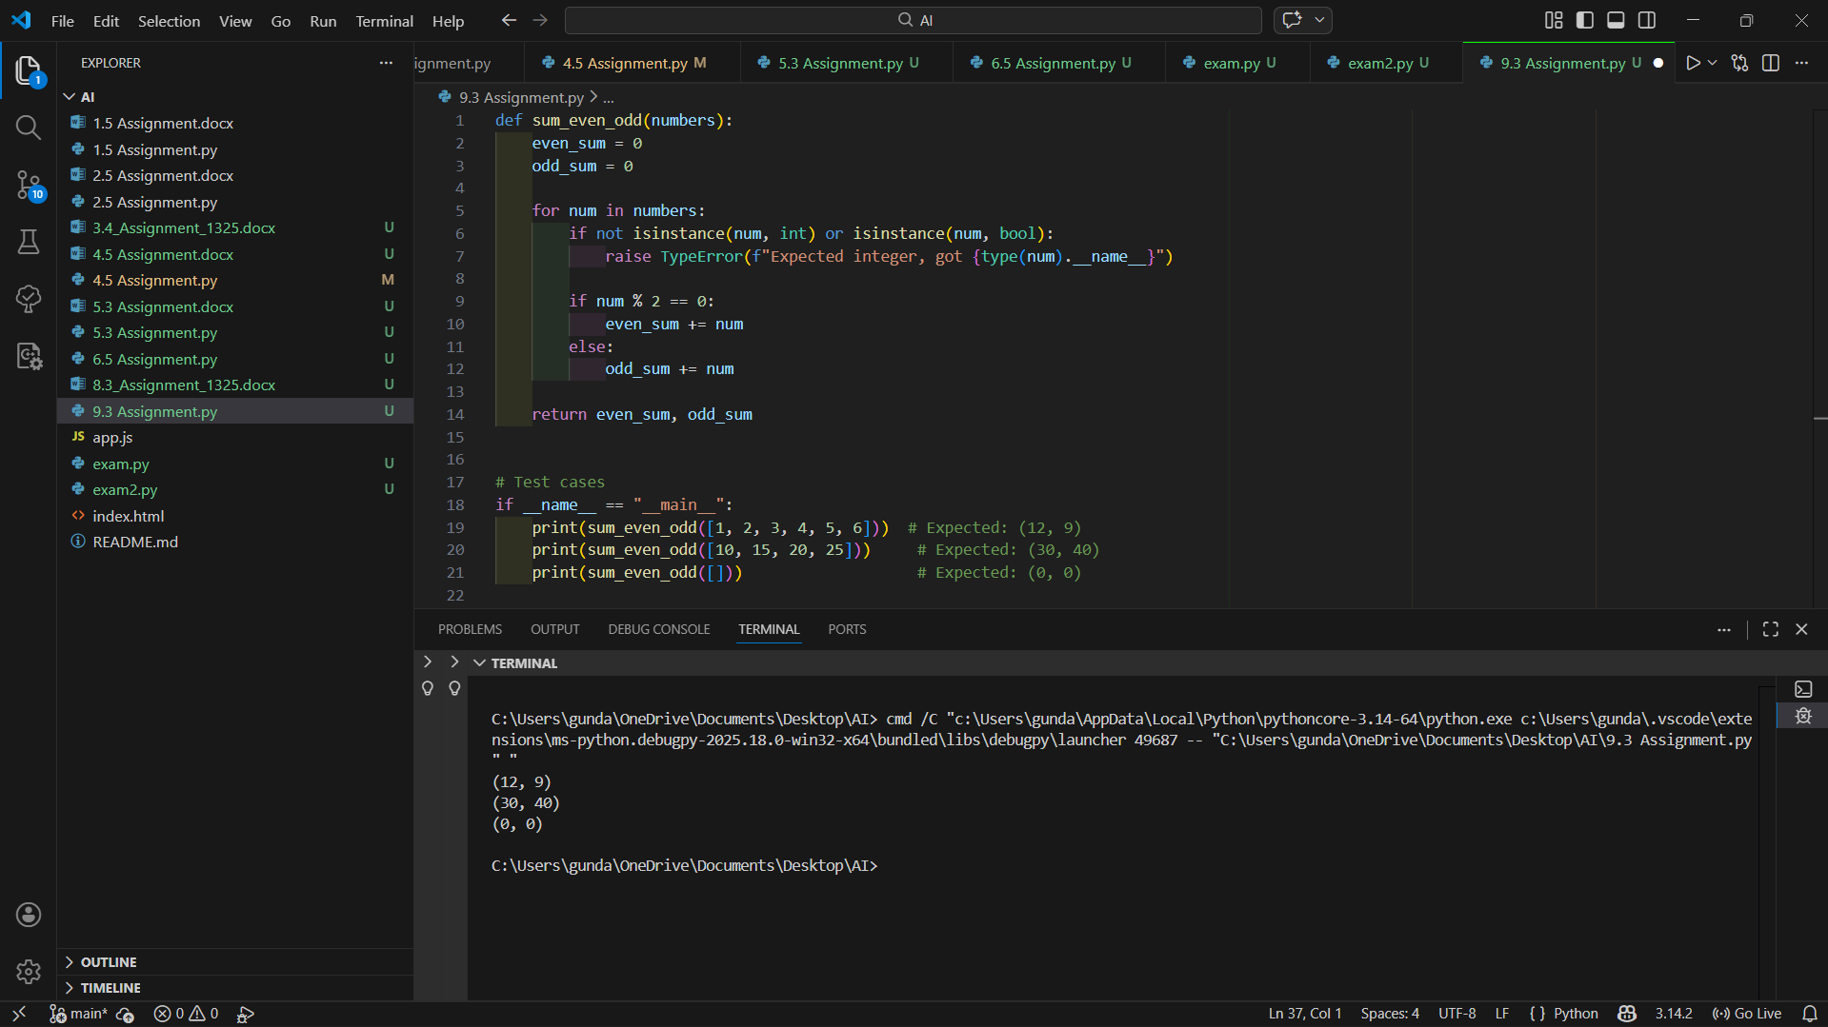
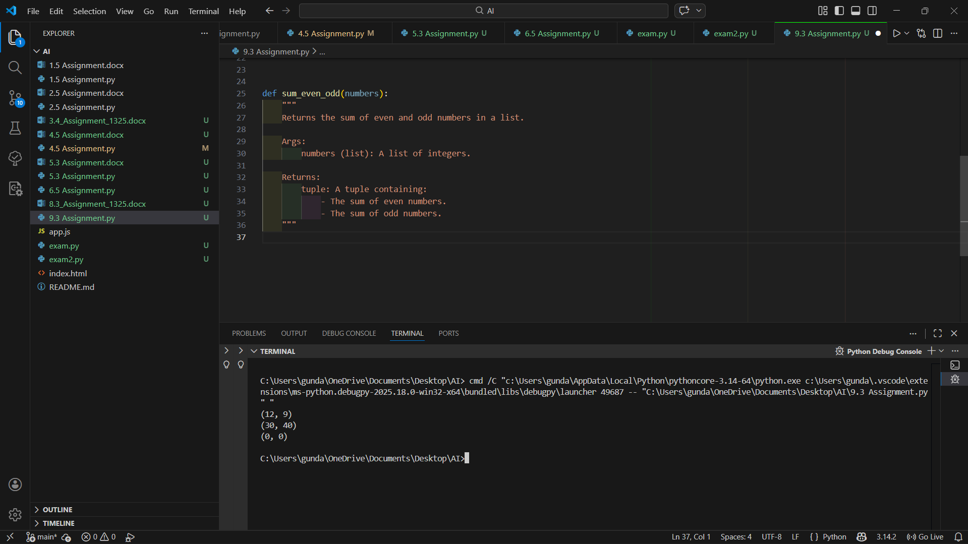
Task 2: Automatic Inline Comments

Prompt:
Create sru_student class with attributes and methods. Add manual inline comments and compare with AI-generated comments.

Manual Inline Comment Version:
class sru_student:
# Initialize student object
def __init__(self, name, roll_no, hostel_status):
self.name = name # Student name
self.roll_no = roll_no # Student roll number
self.hostel_status = hostel_status # Hostel status (Yes/No)
# Update student fee
def fee_update(self, amount):
self.fee = amount
# Display student details
def display_details(self):
print("Name:", self.name)
print("Roll No:", self.roll_no)
print("Hostel Status:", self.hostel_status)

AI-Generated Inline Comments (Simulated):
class sru_student:
def __init__(self, name, roll_no, hostel_status):
# Constructor method
self.name = name
self.roll_no = roll_no
self.hostel_status = hostel_status
def fee_update(self, amount):
# Assign fee value
self.fee = amount
def display_details(self):
# Print details
print("Name:", self.name)
print("Roll No:", self.roll_no)
print("Hostel Status:", self.hostel_status)

Code Explanation:
The class stores student details, updates fee information, and prints student information.

Sample Output:
Name: Manoharreddy
Roll No: 2303A51325
Hostel Status: Yes

Comparison:
Manual comments explain logic clearly. AI comments are shorter and sometimes obvious. AI may miss context or deeper explanation.
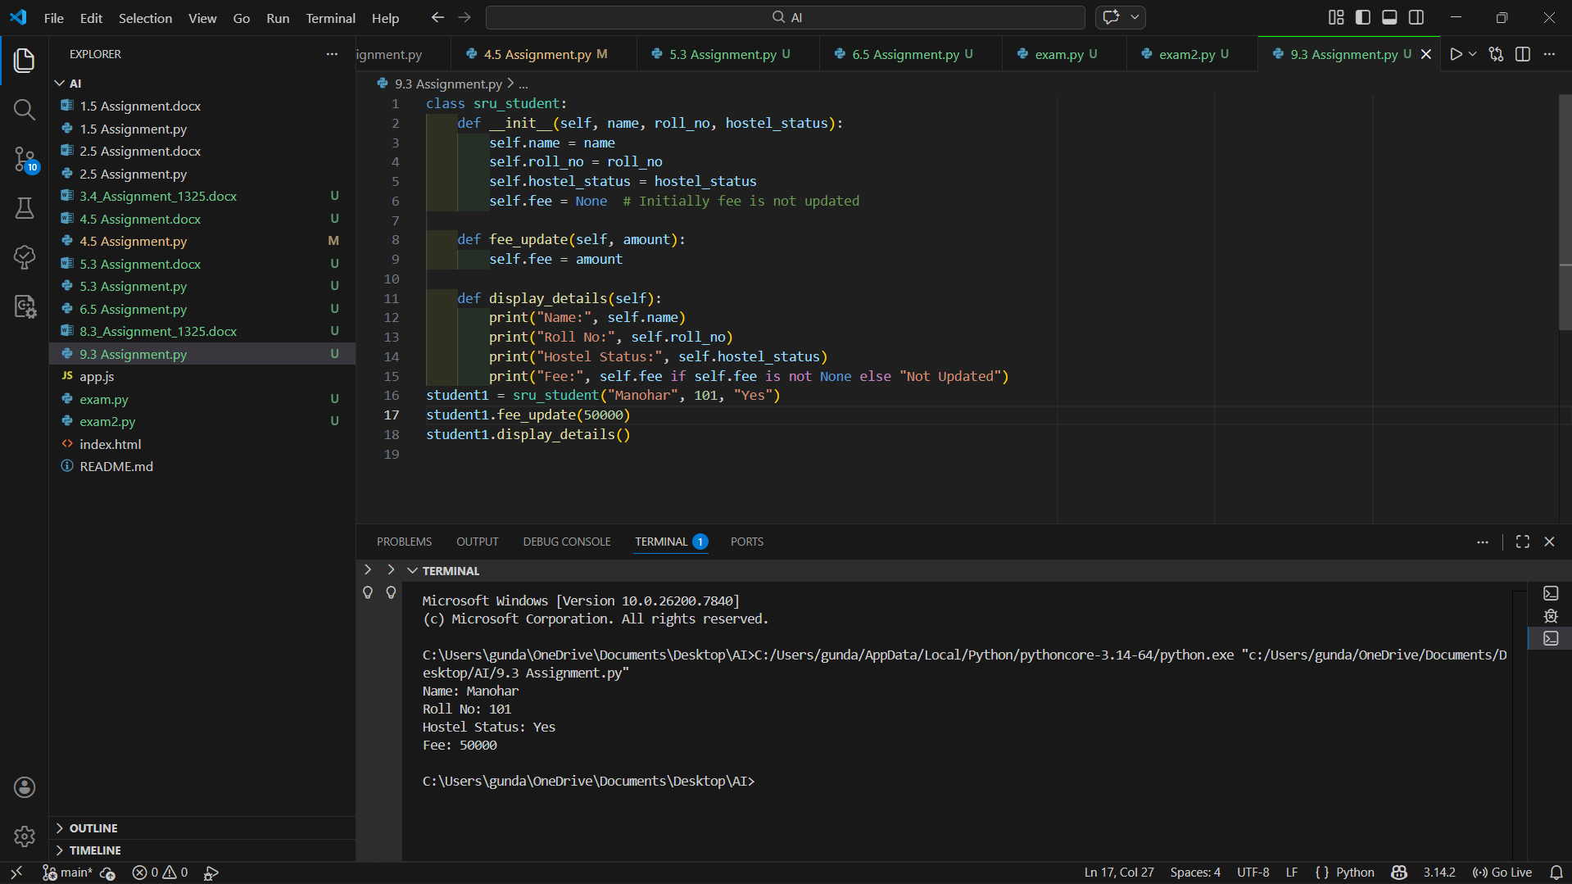
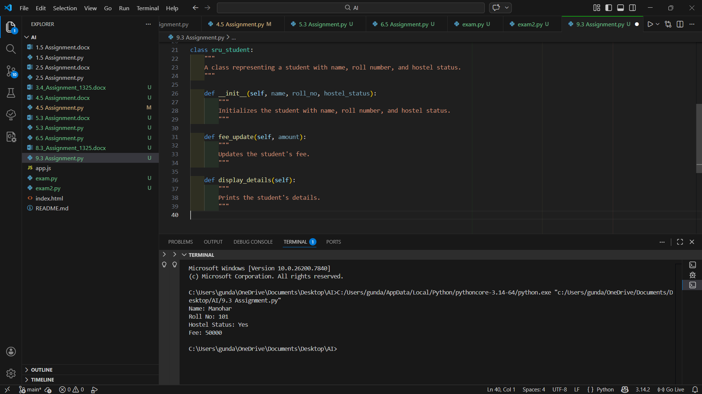

Task 3: Module-Level and Function-Level Documentation

Prompt:
Create calculator functions. Add manual NumPy-style docstrings. Generate AI module-level docstring. Compare both.

Manual NumPy-Style Function Docstring:
def add(a, b):
"""Add two numbers.
Parameters
----------
a : int or float
b : int or float
Returns
-------
int or float
Sum of a and b.
"""
return a + b
def divide(a, b):
"""Divide two numbers.
Parameters
----------
a : int or float
b : int or float
Returns
-------
float
Raises
------
ZeroDivisionError
"""
if b == 0:
raise ZeroDivisionError("Cannot divide by zero")
return a / b

AI-Generated Module-Level Docstring (Simulated):
"""
This module provides basic arithmetic operations such as addition,
subtraction, multiplication, and division.
"""

Code Explanation:
The calculator module performs arithmetic operations with structured documentation for better maintainability.

Sample Output:
add(5,3) → 8
divide(10,2) → 5.0

Comparison:
Manual NumPy-style docstrings are more structured and detailed. AI-generated module documentation is concise but lacks parameter depth.
